Concept Document – Gravity Run

by Melvin Magro, Naomi Zammit Ciantar, Maria Grech and Paul Falzon

**General Idea**

The idea behind this game is to show how immersion can be developed into a 2D game. Our inspiration games where: Super Mario, Jetpack Joyride, Adventure runner and subway surfer. We tried to combine these mobile addicting games into one game that can be played for a long time.

**Psychological Concept of Play**

Our psychological aspect if the game is immersion and we tried giving the immersion feeling by giving the player only one button to press which switches the gravity. By giving the player less buttons to learn the game, the player will get into the game much faster. Throughout the level, every 10 drops collected, it will increase the game speed and the screen will become smaller. This way the flow of the game will not stay the same but it will become a bit harder by time. Also players will not be bored with the same flow but will stay hooked for a while to spend their time on.

**Rules**

* Player needs to pick colour drops to score points
* Player cannot hit the black drop or he will lose
* Player must use the space button to switch gravity

**Mechanics**

* Pressing space will switch gravity (either up or down)
* Picking drops will colour the background and score points

**Iteration Description**

The game will start with the back story and when the next button is pressed 3 times the game starts. Black drops and colour drops will be in your character’s way and you need to evade black drops and pick up colour drops. By changing the gravity you can play around black drops and pick up the colour drops. When hitting a black drop the game will end. When hitting a colour drops, the score will increment and every 10 colour drops collected the game will continue at a faster rate with the screen size reducing.

**Sketches**

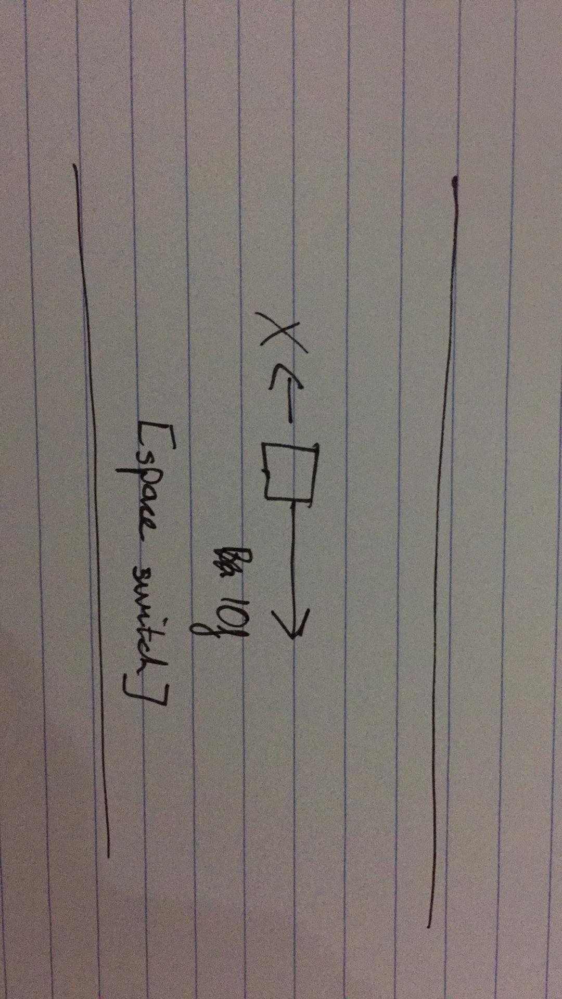

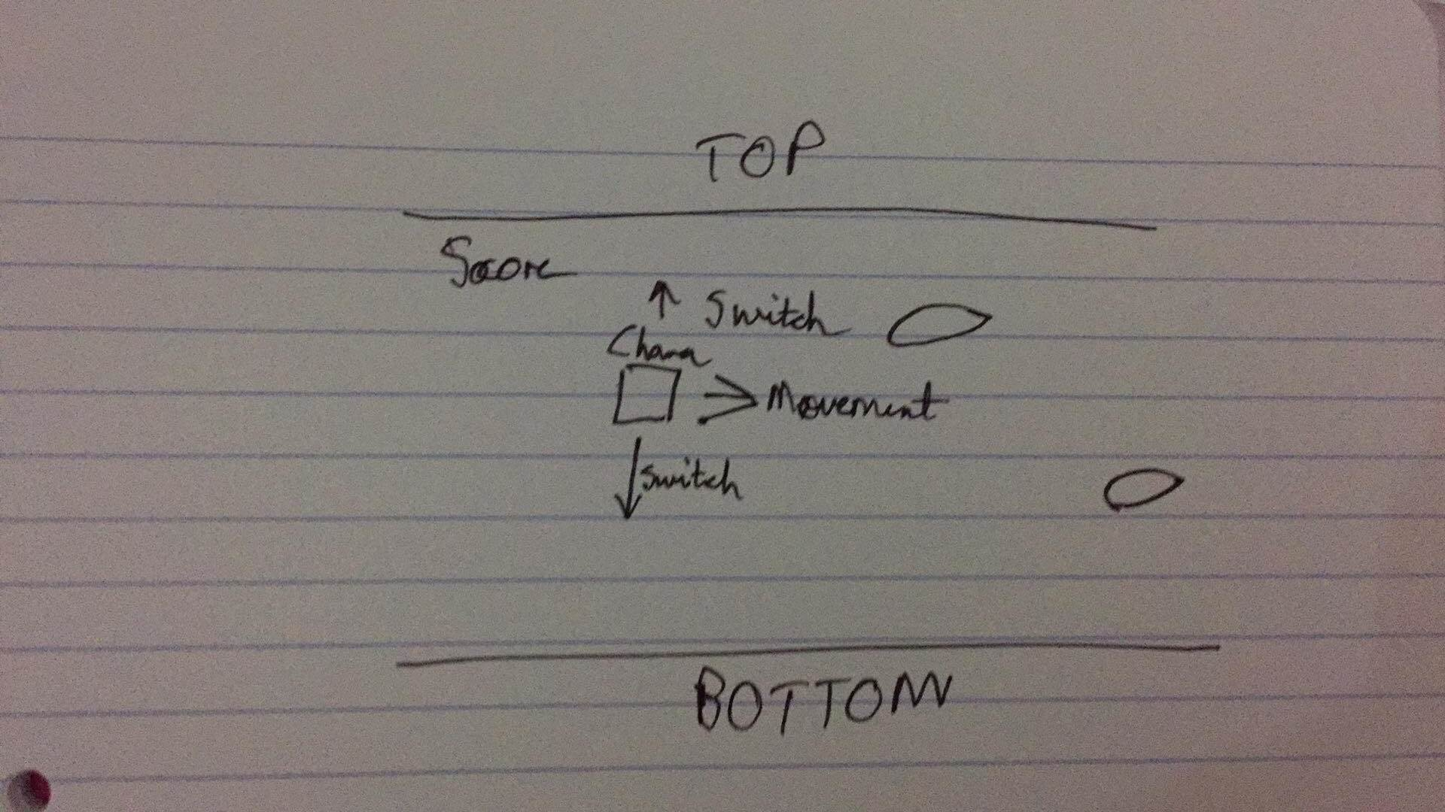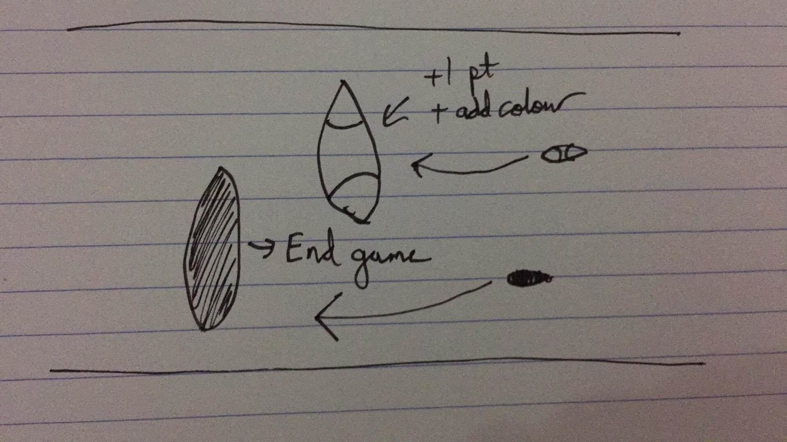

**Renders**

Storyline page 1

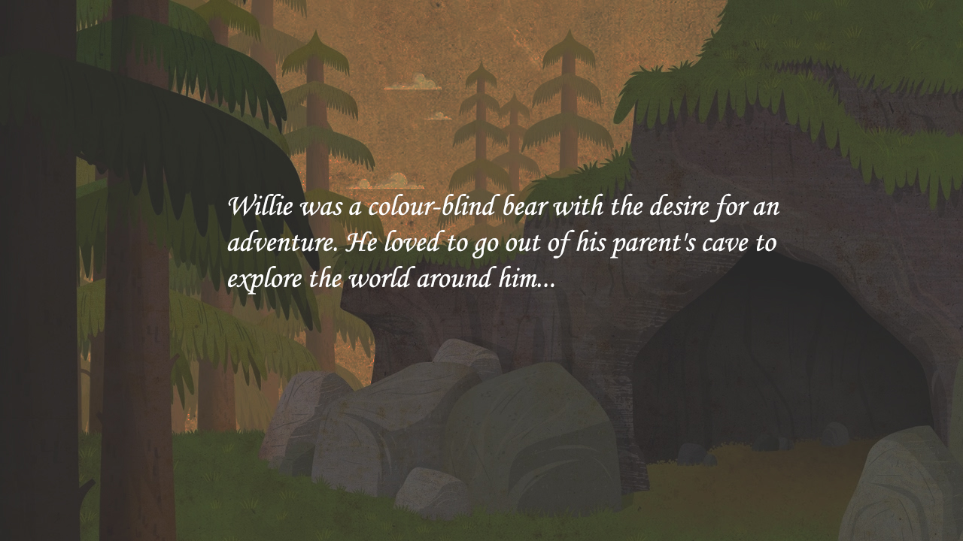

Storyline page 3

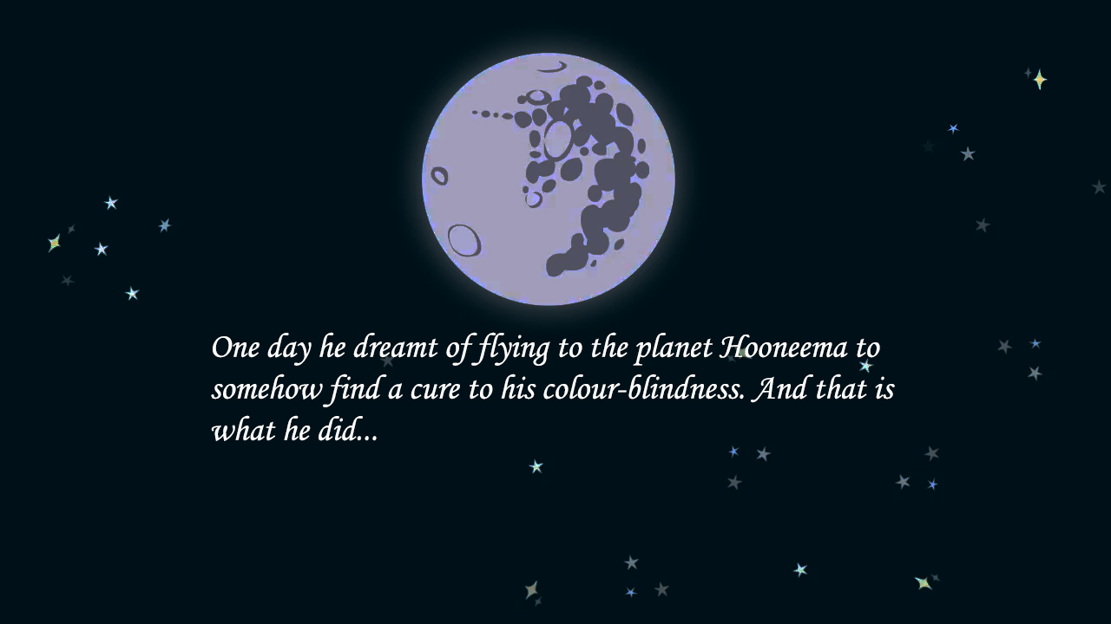

Start of the game

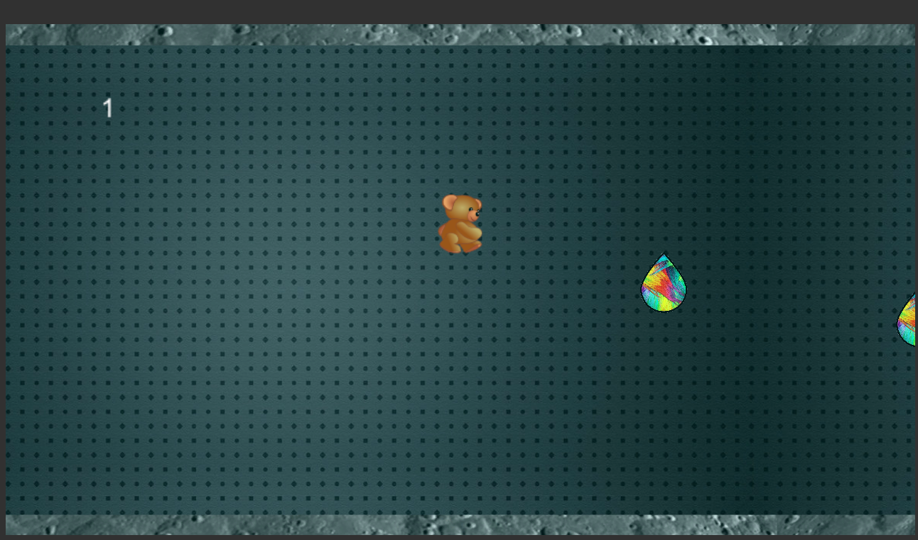

10 drops collected – Screen getting smaller – the use of spacebar

